Child Education Software

Arindam Ghosh

Table of Contents :-

1. Introduction & Objective of the Project: 4
2. Project Category: 5
3. Tools/Platform, Hardware and Software Specification 5
3.1 Hardware and Software Specification 5
3.1.1 Hardware Requirements 5
3.1.2 Software Requirements 5
3.2 Tools/Platforms used (Hardware/Software): 5
3.2.1 Hardware Used 5
3.2.2 Software Used 5
4. REQUIREMENTS AND ANALYSIS 6
4.1 Problem Definition 6
4.2 Requirements Specification 6
4.2.1 Functional Requirements 6
4.2.1.1 Audio visual display of study materials: 6
4.2.1.2 Exercise for students: 6
4.2.1.3 Drawing pane for practice 7
4.2.1.4 Download new lesions: 7
4.2.1.5 Learn about various topics like nature, economy etc. 7
4.2.1.6 Online payment 7
4.2.1.7 Easily sharable downloaded lesions: 8
4.2.1.8 Generate grade card 8
4.2.2 Technical Specification 8
4.3 Planning and Scheduling 8
4.3.1 Gantt chart 8
4.3.2 Tracking Gantt 9
4.3.3 Pert chart (Network Diagram) 10
5. Scope of the Solution 11
6. Analysis 12
6.1 Context Diagram 12
6.2 Data Flow Diagram 12
6.2.1 Level 0 DFD 12
6.2.2 Level 1 DFD 13
6.2.3 Level 2 DFD 14
6.3 E-R Diagram 15
6.4 Class Diagram 17
7. Database & Table Details 19
8. COMPLETE DATA STRUCTURE 19
8.1 Module Description 19
8.1.1 Child Education Software GUI: 19
Tutorial Selection Interface: 20
Text Pane: 20
Common Controls: 20
Engine Interaction: 21
Video Player / Image Viewer / Audio Player: 21
Drawing Pane: 21
Tutorial Navigator: 21
Online Store Interface: 21
8.1.2 Child Education Software Engine: 22
Tutorial Controller: 22
GUI Interactor: 24
Database Manager: 25
Image Controller: 25
Archive Manager: 25
Video /Audio Controller: 25
Online Store Controller: 25
8.1.3 Child Education Software Database: 25
8.2 Estimation 25
8.3 Data Structure 26
8.4 Implementation Methodology 30
8.5 List of Reports 30
9. Implementation of Security Mechanism at Various Levels 31
10. Future Scope and Further enhancement of the project: 31
11. BIBLIOGRAPHY 31

Introduction & Objective of the Project:
Child Education Software will enable a new aspect of teaching children with the help of modern technology. It will incorporate audio visual teaching method with user friendly interface. Almost every family is having a computer now. We are used to computerized system in every walk of our life. So kids also will be attracted towards computer. We can use computer as a mean of teaching new things. Because of rich multi-media content kids will be happy to use computer for learning new topics.
In Child Education Software users can use the existing tutorial as well as they can download new tutorial from online store. It will be an eco friendly option. Children wastes paper a lot and they get bored as the colour of the fades gradually. The child education software will make learning more efficient, attractive and tech-savvy for the children.

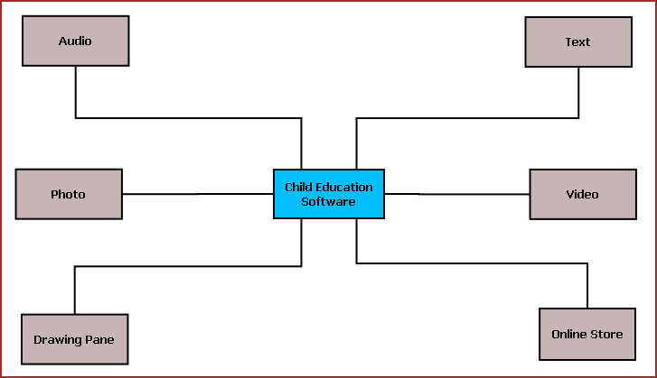
Figure 1: Overview of Child Education Software
The main features of this software are listed below:
  - Textual display of teaching material.
  - Video display for video tutorial.
  - Sound system to play audio clips.
  - Drawing Pane or Handwriting practice area.
  - Photo viewer.
  - Easy navigation.
  - Interactive UI.
  - Printing of selected content.
  - Online store for buying new tutorials and upgrades.

Project Category:

This software will follow Object Oriented Programming Paradigm and use below mentioned areas.

OOP Language: C#
RDBMS: MySQL 5.5.15
Networking: TCP/IP
Applications: Expert Systems, Educational application

Tools/Platform, Hardware and Software Specification

Hardware and Software Specification

Hardware Requirements
- Computer that has a 1.6GHz or faster processor
- 1 GB (32 Bit) or 2 GB (64 Bit) RAM
- 10 MB of available hard disk space
- DVD-ROM Drive / USB Port

Software Requirements
- Windows XP (x86) with Service Pack 3 / Windows Vista (x86) with Service Pack 2 / Windows 7 (x86)
- Microsoft .NET 4.0

Tools/Platforms used (Hardware/Software):

Hardware Used
- Laptop with 2GHZ processor
- 2 GB RAM
- 320 GB hard disk (NTFS File System)

Software Used
- Windows XP (x86) with Service Pack 3 / Windows Vista (x86) with Service Pack 2 / Windows 7 (x86)
- Microsoft .NET 4.0
- Windows Presentation Framework(WPF)
- Windows Communication Framework(WCF)
- Visual Studio 2010 Express Edition (IDE)
- MySQL Workbench
- Dia for Diagram Drawing & Modeling.

REQUIREMENTS AND ANALYSIS

Problem Definition
Now we are used to computerized system in every walk of our life and kids also will be attracted towards computer. We can use computer as a mean of teaching new things. Because of rich multi-media content kids will be happy to use computer for learning new topics. Since we are also dedicated to the education we are always searching for ways to create educational material which starts from "simple" alphabets to complex grammar exercises and study material for other subjects such as science, mathematics, history etc. Our primary focus is on schoolchildren aged 3 to 18, and the specialized user interface needs of young users. However, we will also have programs to aid teachers in planning lessons, and others that are of interest to university students and anyone else with a desire to learn.

CES will allow participants to have lessons from offline resources as well as online study materials. They can also do a hands-on with the exercises and evaluate their progress. Additional study material and tool can be availed by purchasing modules from various online resources.

Requirements Specification

Functional Requirements

Audio visual display of study materials:
Introduction:
User should be able to watch animated video lessons as well as audio lessons.
Input:
Click on show lesion button.
Processing:
System will find and fetch a predefined lesion and display that.
Output:
Kids can watch them and learn new things.

Exercise for students:
Introduction:
There should be relevant and user friendly exercise topics.
Input:
User will click on start practice button.
Processing:
System will open relevant practice set for kids from database.
Output:
Kids can interact with the graphical practice sets and solve them.

Drawing pane for practice
Introduction:
There should be a drawing pane for kids with an attractive GUI.
Input:
User will click on start drawing button and kids will start interacting with the GUI.
Processing:
Drawn shapes will be saved temporarily in memory and could be permanently kept in database.
Output:
Stored drawings will be shown to the user whenever is asked.

Download new lesions:
Introduction:
New lesions could be downloaded from the web if user wants.
Input:
User clicks on download new lesions button.
Processing:
System searches for relevant data in the previously stored online database and copies them in the local system.
Output:
System shows the newly downloaded lesions to the user.

Learn about various topics like nature, economy etc.
Introduction:
There should be various GK tutorials with relevant images and examples.
Input:
User clicks on the learn button.
Processing:
Various options provided to the user and as per his choice a new image and description gets opened.
Output:
Students get to see topics with images and examples that help them remember the topics better.

Online payment
Introduction:
For purchasing lesions, user should be able to pay online using debit card, internet banking, credit card etc.
Input:
User opts for online payment option in the application GUI.
Processing:
After getting required details, system takes user to his banker’s website and deducts the required amount. Generates a online bill as well.
Output:
User gets the digital bill’s copy in his email inbox and gets the new lesion in his system as well.

Easily sharable downloaded lesions:
Introduction:
People should be able to share the lesions to other computers.
Input:
User clicks on share the lesions button
Processing:
System takes the tutorials from database and sends them to the portable device as per user choice for sharing.
Output:
User gets the data and could easily copy them to the other portable device.

Generate grade card
Introduction:
After completing exercises, a grade card should be generated.
Input:
Kids complete the exercises within the given time.
Processing:
After matching the answers with predefined answers, system generates a report card and saves them in database.
Output:
User can see the report card after the exam and see them in future as well.

Technical Specification
Front End/ GUI Tools: Windows Presentation Framework (WPF)
IDE: Visual Studio 2010
Framework: Microsoft .NET 4.0
Database: MySQL
Database Tool: MySQL workbench CE
Operating Systems: Windows XP, Windows 7
Cloud Technology: Google Drive, Google forms

Planning and Scheduling

Gantt chart

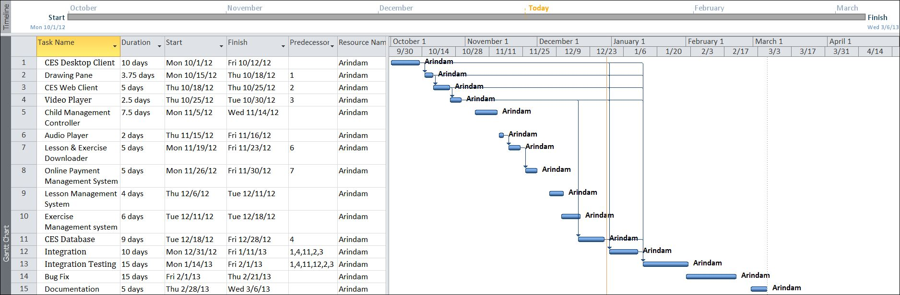

Tracking Gantt

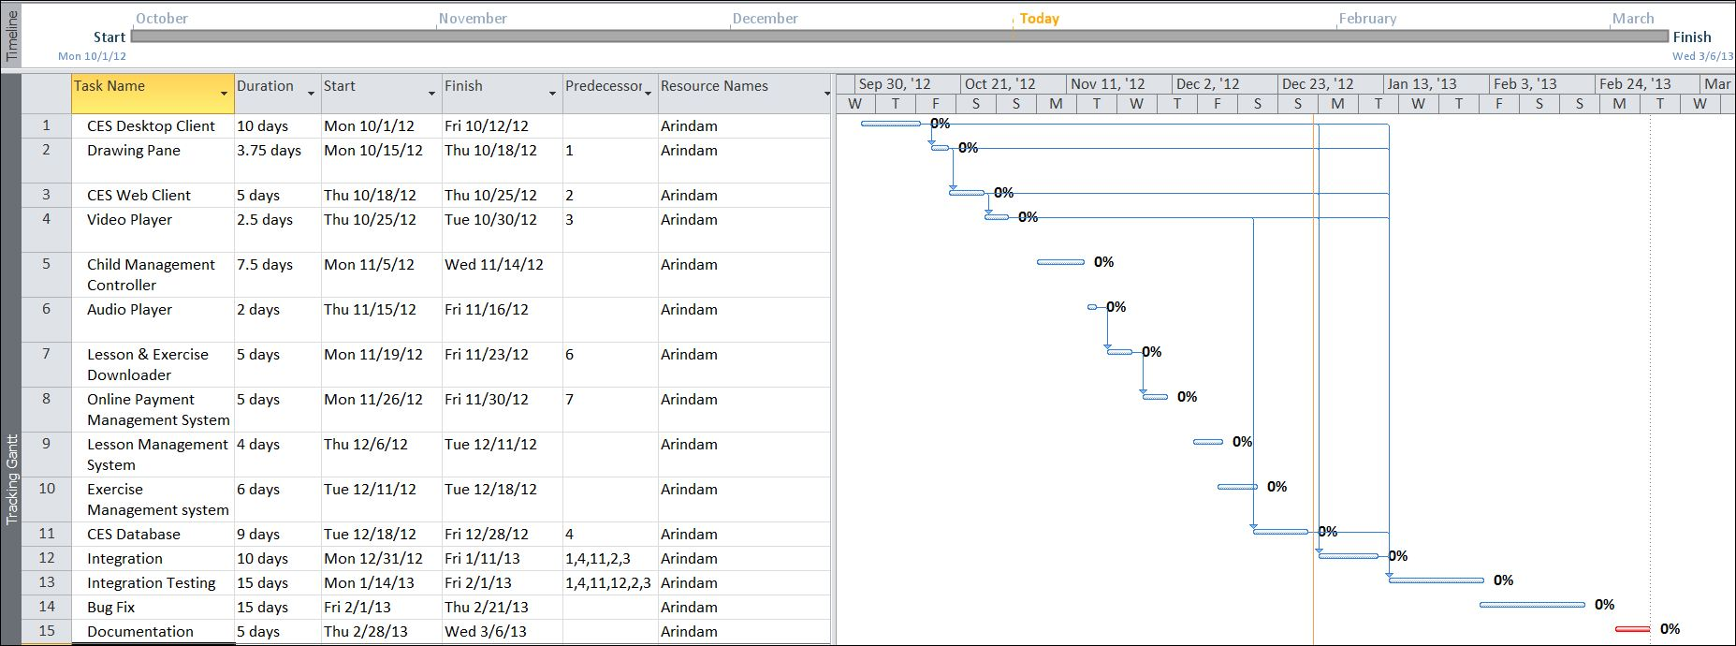

Pert chart (Network Diagram)
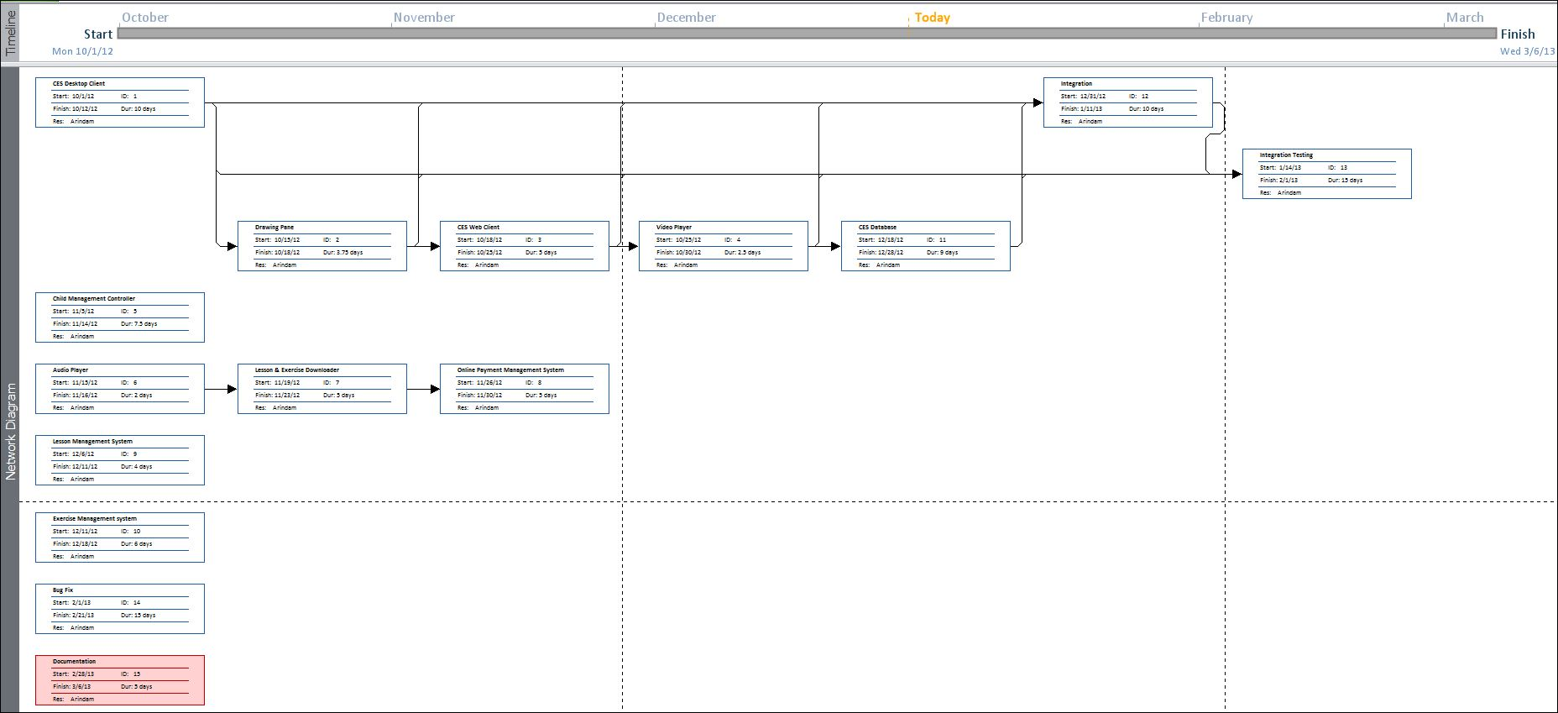

Scope of the Solution
Child Education System provides the most complete and configurable full-service computerized solution for education and automation.CES will allow participants to have lessons from offline resources as well as online study materials. They can also do a hands-on with the exercises and evaluate their progress. Additional study material and tool can be availed by purchasing modules from various online resources.

Since early teaching days we have been convinced that children, as individuals have different learning needs. The challenge has always been to deliver the right educational content at the right time for the right child and then to motivate them to access it. The Child Education System range has grown from this conviction and treats each child as an individual with unique user profiles, advanced record keeping and high levels of customisation, allowing each child to work at their own pace and to know the reward of success.

At The Child Education System, we build our software knowing that every child’s learning needs are different. We want every child to experience the joy of knowing they can face a learning challenge and know success. Whether struggling or flying, there’s a place for every learner.

Analysis

Context Diagram
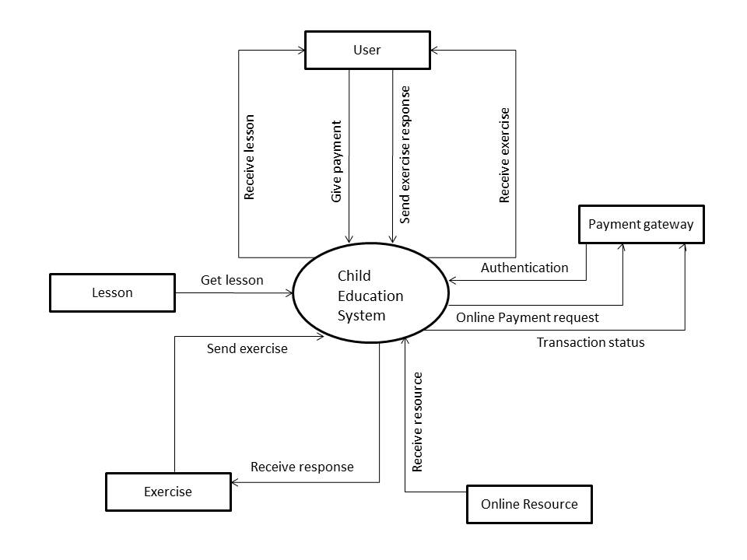
Figure 1: Context Diagram of CES

Data Flow Diagram

Level 0 DFD
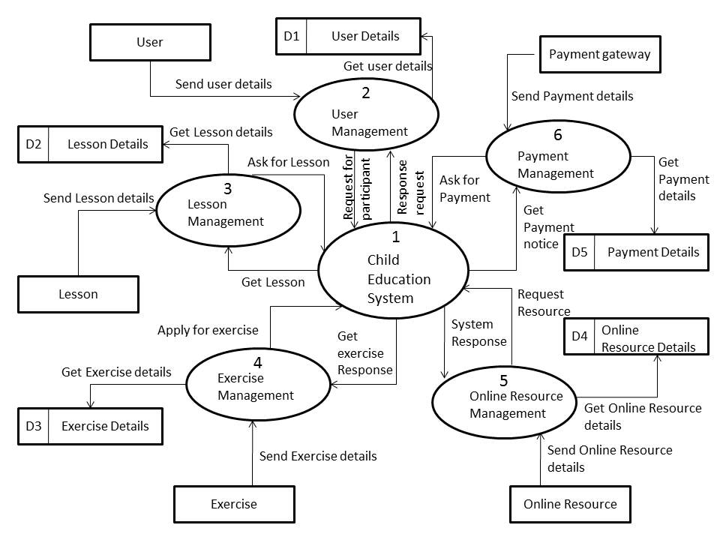
Figure 2: DFD level 0 of CES

Level 1 DFD
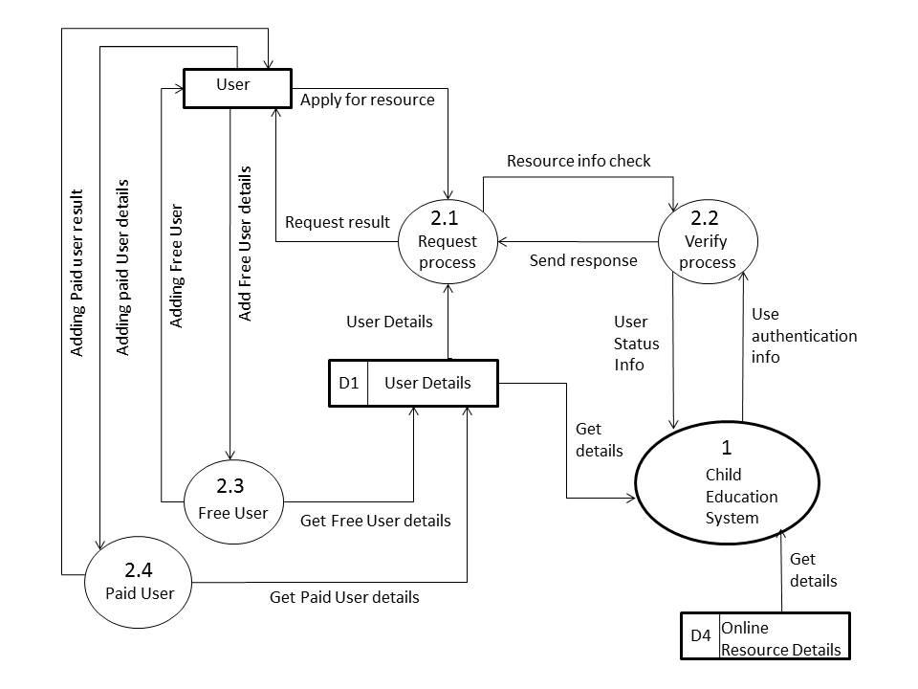
Figure 3: DFD level 1 of CES
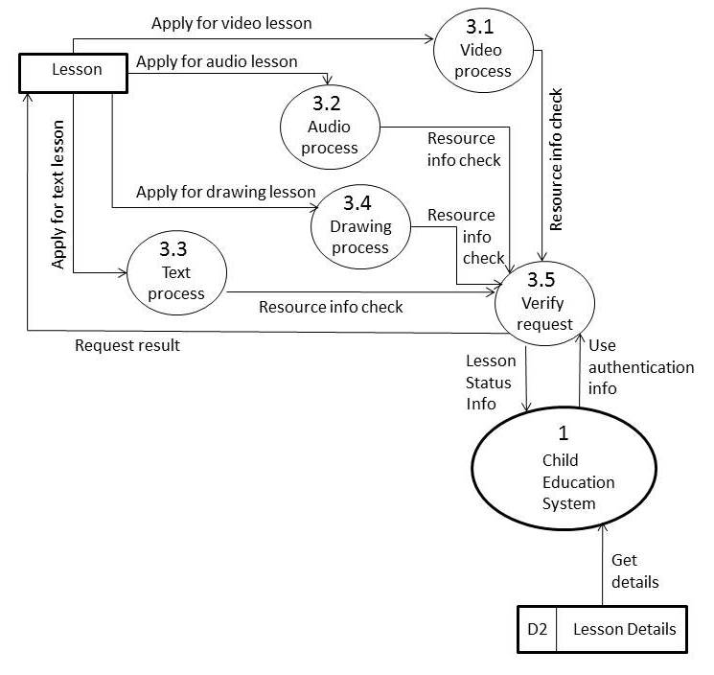
Figure 4: DFD level 1 of CES
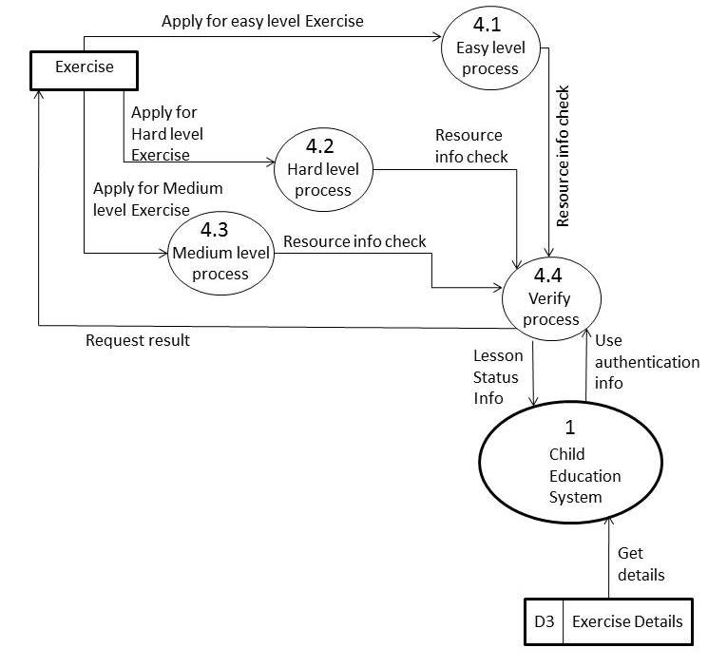
Figure 5: DFD level 1 of CES

Level 2 DFD
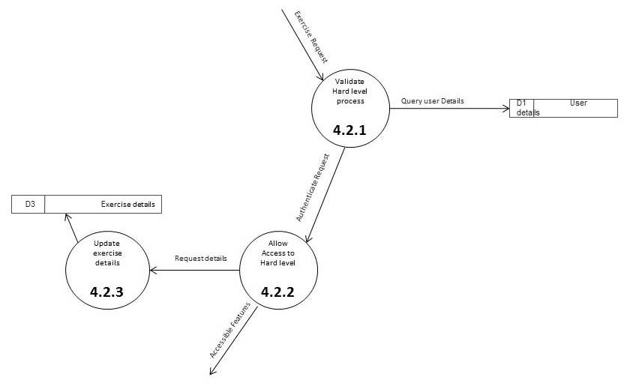
Figure 6: DFD level 2 of CES

E-R Diagram
We will design a RDBMS for Child Education Software. The entities and their attributes are listed below. Attributes in Bold letter is the unique key.

Entities | Attributes
Tutorial | Tutorial Id, Name, Base Path, Last Visit Time, Size, Thumbnail, video path, image path, audio path, scribble image path
Child Education Software | Software Id, Total tutorials , Occupied Size
User | User Id, Name, Social Network Data, password, Preferences.

Relationship between Entities:

- Child Education Software has Tutorials → 1 : N
- User uses tutorials → M : N

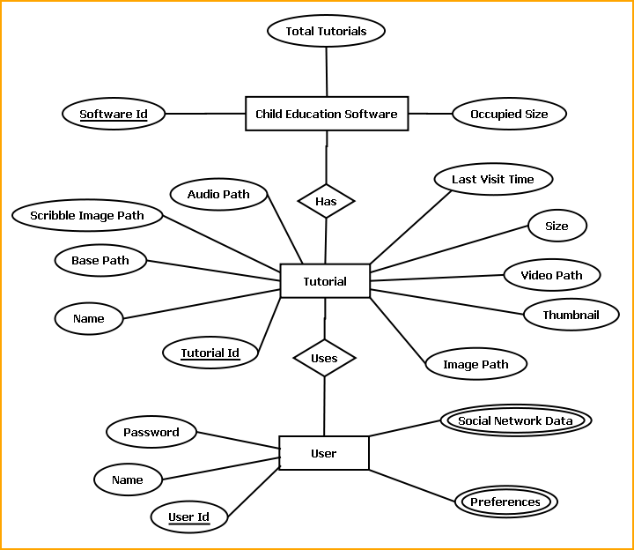

E-R Diagram of Child Education Software

Class Diagram

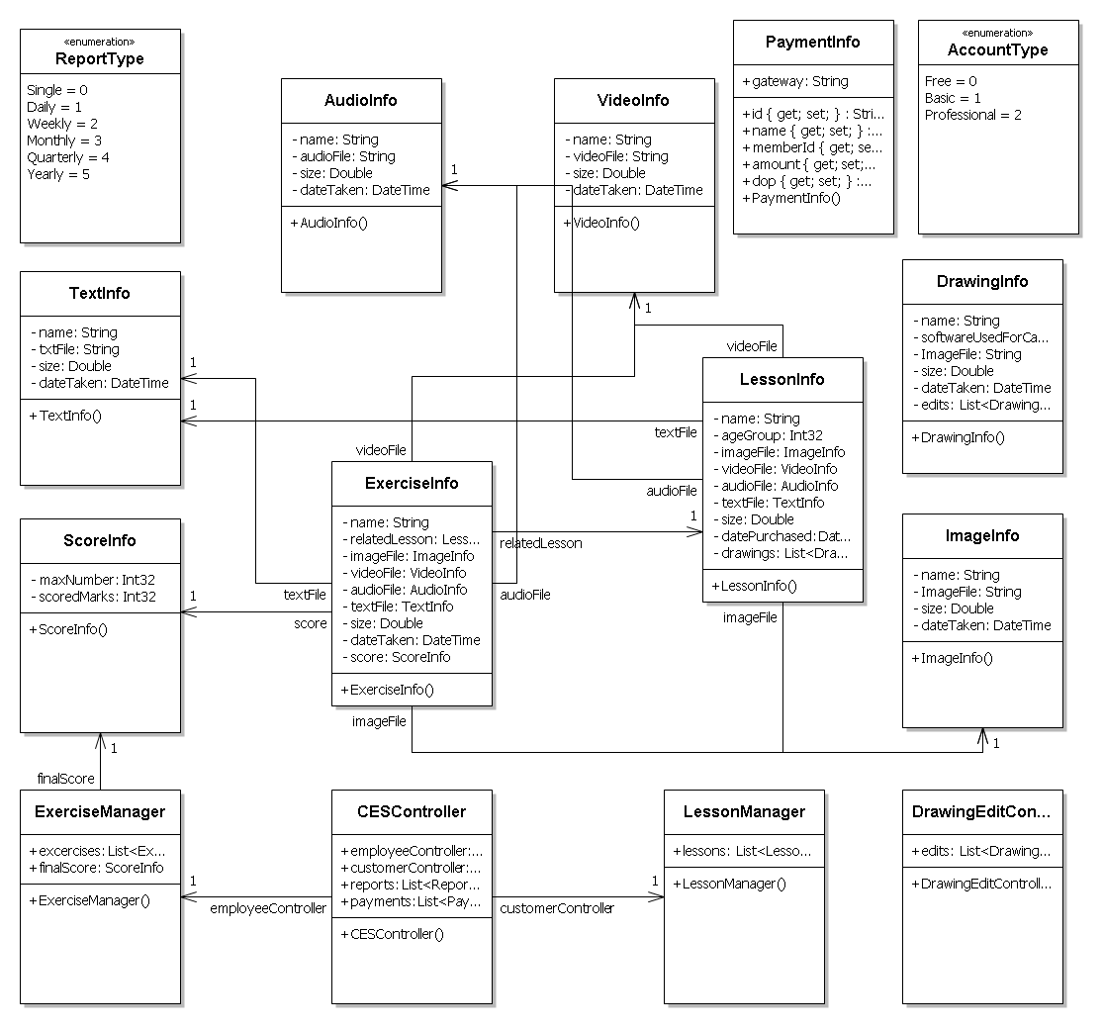
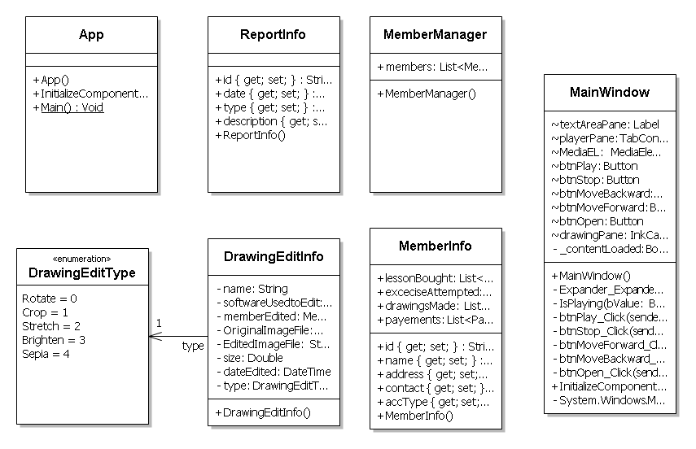

Database & Table Details
The database used for this software is called CESdb. Database tables and corresponding keys are shown in tabular form. It shows the tables and its columns. A key in Bold is the primary key.

Tables | Keys
Tutorial | Tutorial Id, Name, Base Path, Last Visit Time, Size, Thumbnail, video path, image path, audio path, scribble image path
Child Education Software | Software Id, Total tutorials , Occupied Size
User | User Id, Name, Social Network Data, password, Preferences.

COMPLETE DATA STRUCTURE

Module Description
Child Education Software is divided into three main modules.
- GUI
- Engine
- Local Storage & Online Storage

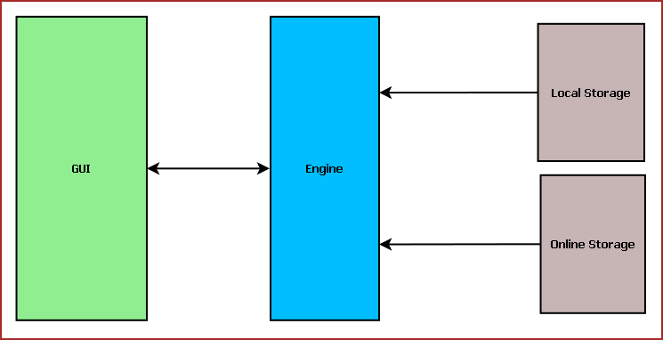
Figure: Child Education System Components

Child Education Software GUI:
Child Education Software GUI will display tutorial, navigator, online store interface. The main components of GUI are:
- Tutorial Selection Interface
- Text Pane
- Video Player / Image Viewer / Audio Player
- Drawing Pane
- Tutorial Navigator
- Common Application Control
- Online Store Interface
- Engine Interactor

Tutorial Selection Interface:
This interface will display the available tutorials from local storage and the tutorials bought from Online Store. From here the user will select the tutorial to be viewed. The tutorials will be displayed according to different category such as: Age, Subject, culture etc.

Text Pane:
This area will display the text portion of the tutorial. This will contain the description about the subject if different colors. Users can select text, copy and paste the text.

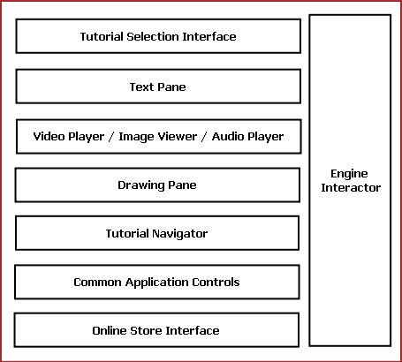
Fig: Components of Child Education Software GUI

Common Controls:
Common controls include several controls of the application. Such as: Menu Bar, Toolbar, status bar, Context Menu and progress bar.

Engine Interaction:
This module handles the interaction between GUI and Engine. This module defines all callback for the Engine events.

Video Player / Image Viewer / Audio Player:
This Pane displays the image, video & audio artwork associated with the tutorial content. This will have two components such as: Display Area & Control Pane. Display Area will display the content. Control Pane contains the control like Play, Pause, Previous, Next for controlling the displayed content.

Drawing Pane:
Drawing Pane allows user to draw, sketch & scribble. This will help the kids to draw and practice while learning. User can save the drawing as a Image or load a image to scribble.

Tutorial Navigator:
This pane contains the controls for navigating within the tutorial. It will have “Next”, “Previous” and “Go to Home” options.

Online Store Interface:
This pane allows user to login into Online Store. Then it will display the available tutorial online for download. User may need to purchase or download it for free.

The GUI layout of Child Education Software is shown below:

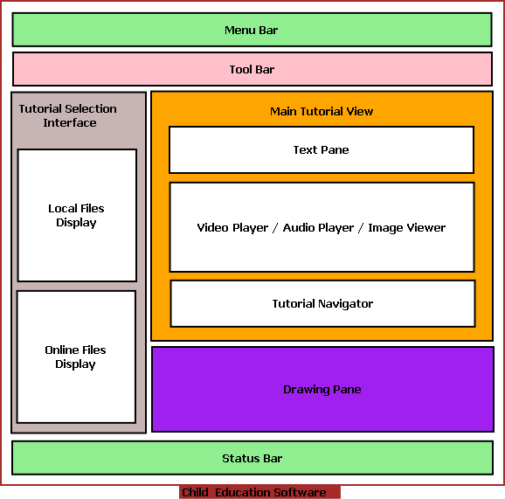

Child Education Software Engine:
Child Education Software Engine provides multimedia framework for displaying Video/Image, tutorial controlling logic. It is mainly divided into following components:
- Tutorial Controller
- Image Controller
- Archive Manager
- Video /Audio Controller
- Online Store Controller
- GUI Interactor
- Database Manager

Tutorial Controller:
This module defines the tutorial format. It controls tutorial flow, content to be displayed. Every tutorial is internally a XML file mentioning the tutorial contents.
The xml follows the below mentioned format.

<?xml version="1.0" encoding="utf-8" ?>
<tutorial>
<page>
<Sequence>1</Sequence>
<text> A for Apple</text>
<video-path>.\\Videos\\apple.mp4</video-path>
<audio-path>null</audio-path>
<image-path>null</image-path>
<scribble-path>.\\Images\\apple.jpg</scribble-path>
</page>
<page>
<Sequence>2</Sequence>
<text>B for Ball</text>
<video-path>.\\Videos\\ball.mp4</video-path>
<audio-path>null</audio-path>
<image-path>null</image-path>
<scribble-path>.\\Images\\ball.jpg</scribble-path>
</page>
<page>
<Sequence>3</Sequence>
<text>C for Cat</text>
<video-path>null</video-path>
<audio-path>.\\Audios\\cat.mp4</audio-path>
<image-path>.\\Images\\cat.jpg</image-path>
<scribble-path>.\\Images\\cat.jpg</scribble-path>
</page>
</tutorial>

Tutorial controller has a XML parser to read the XML and load tutorial contents accordingly. Tutorial Controller controls the other engine components to coordinate tutorial display.
Different components of Child Education Software Engine and their interaction with other modules are displayed in the following diagram.
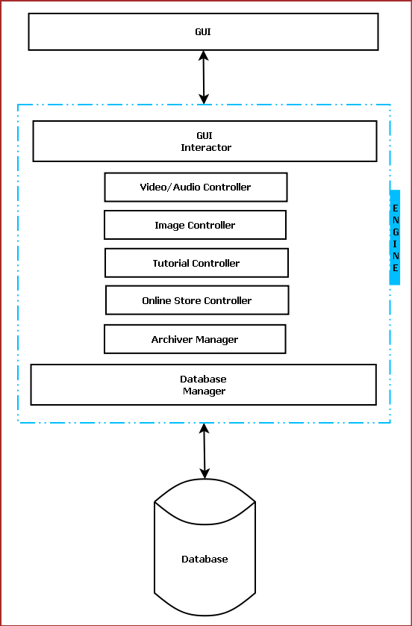
Figure: Interaction among different components of Child Education Software

GUI Interactor:
This module interacts with GUI module and serves GUI action request.

Database Manager:
This module manages the database. It handles information saving in database, retrieval of information from database.

Image Controller:
This module provides the framework to display an image and to save a drawing to as image. We will use Open Source JPEG library to decode and encode images.

Archive Manager:
This module archives old and less frequently used tutorials to save space. We will use Open Source 7z archive framework for archiving.

Video /Audio Controller:
Video/Audio Controller handles the encoding and decoding of video and audio files. We will use Open Source GStreamer framework for video/audio playback features.

Online Store Controller:
This module controls the Online searching, purchasing and downloading of new tutorials. It allows the users to browse through available tutorial. We will use Chrome Webkit browser framework and Jhomla PHP framework to implement online store.

Child Education Software Database:

Child Education Software Database will be an optimized database which will save certain information about the tutorials. We will use RDBMS concept.

Estimation

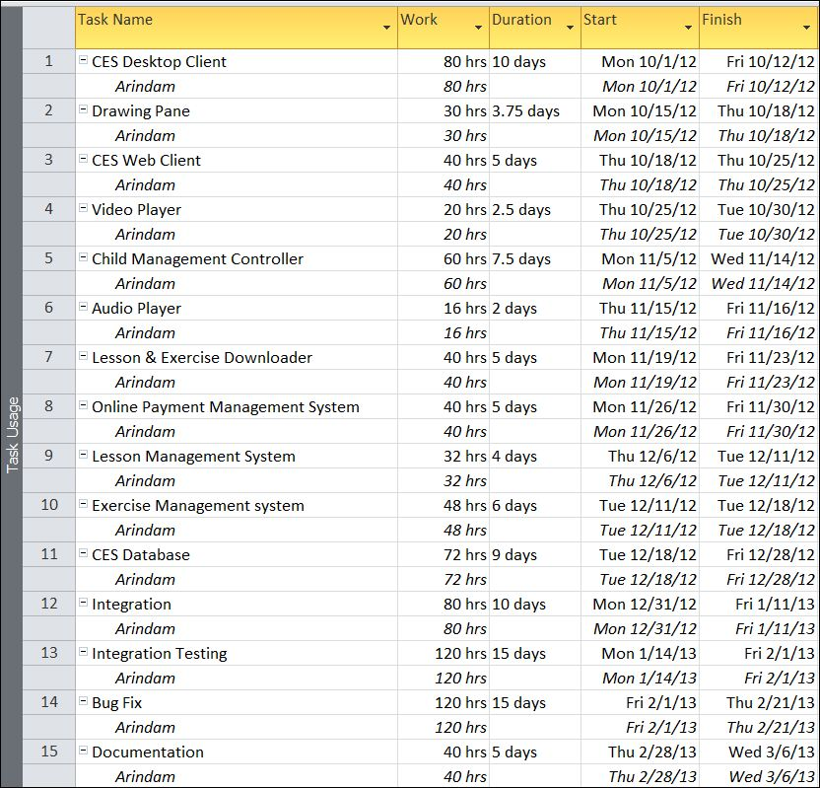

Data Structure

LessonInfo
public class LessonInfo
{
string name;
int ageGroup;
ImageInfo imageFile;
VideoInfo videoFile;
AudioInfo audioFile;
TextInfo textFile;
double size;
DateTime datePurchased;
List<DrawingInfo> drawings;
}

ExerciseInfo
public class ExerciseInfo
{
string name;
LessonInfo relatedLesson;
ImageInfo imageFile;
VideoInfo videoFile;
AudioInfo audioFile;
TextInfo textFile;
double size;
DateTime dateTaken;
ScoreInfo score;

}

ScoreInfo
public class ScoreInfo
{
int maxNumber;
int scoredMarks;
}

DrawingInfo
public class DrawingInfo
{
string name;
string softwareUsedForCapture;
string ImageFile;
double size;
DateTime dateTaken;
List<DrawingEditInfo> edits;
}

TextInfo
public class TextInfo
{
string name;
string txtFile;
double size;
DateTime dateTaken;
}

AudioInfo
public class AudioInfo
{
string name;
string audioFile;
double size;
DateTime dateTaken;
}

VideoInfo
public class VideoInfo
{
string name;
string videoFile;
double size;
DateTime dateTaken;
}

ImageInfo
public class ImageInfo
{
string name;
string ImageFile;
double size;
DateTime dateTaken;
}

DrawingEditType
public enum DrawingEditType
{
Rotate,
Crop,
Stretch,
Brighten,
Sepia
}

ReportType
public enum ReportType
{
Single,
Daily,
Weekly,
Monthly,
Quarterly,
Yearly
}

ReportInfo
public class ReportInfo
{
public string id { get; set; }
public DateTime date { get; set; }
public ReportType type { get; set; }
public string description { get; set; }
}

PaymentInfo
public class PaymentInfo
{
public string id { get; set; }
public string name { get; set; }
public string memberId { get; set; }
public double amount { get; set; }
public DateTime dop { get; set; }
public string gateway;
}

MemberInfo
public class MemberInfo
{
public string id { get; set; }
public string name { get; set; }
public string address { get; set; }
public string contact { get; set; }
public AccountType accType { get; set; }
public List<LessonInfo> lessonBought;
public List<ExerciseInfo> exceciseAttempted;
public List<DrawingInfo> drawingsMade;
public List<PaymentInfo> payements;
}

CESController
public class CESController
{
public ExerciseManager employeeController;
public LessonManager customerController;
public List<ReportInfo> reports;
public List<PaymentInfo> payments;
}

MemberManager
public class MemberManager
{
public List<MemberInfo> members;
}

ExerciseManager
public class ExerciseManager
{
public List<ExerciseInfo> excercises;
public ScoreInfo finalScore;
}

AccountType
public enum AccountType
{
Free,
Basic,
Professional
}

DrawingEditController
public class DrawingEditController
{
public List<DrawingEditInfo> edits;
}

LessonManager
public class LessonManager
{
public List<LessonInfo> lessons;
}

Implementation Methodology
• Object Oriented Programming methodology will be adopted
• We are using OpenPDN framework for photo-editing APIs
• User interface development will be done in MVC architecture using Windows Presentation Framework.
• Relational DBMS MySQL will be used to implement & execute SQL query to database.
• Agile Software Development model will be used while developing this software.

List of Reports
List of reports that are likely to be generated in this software are given below:
- Content of lesson can be generated
- Content of available exercises can be generated
- Participant scorecard can be generated
- Available online course material can be generated
- Completed assignment can be generated
- Payment Receipt can be generated

Implementation of Security Mechanism at Various Levels
- This software requires a valid password to login and then it allows using any of its features.
- The login password will be saved in encrypted format in database.
- This software will use Google open-id authentication for web interface.
- A backup and restore feature has been used in case of loss of data due to database crash and other problems.

Future Scope and Further enhancement of the project:

- To support UNIX / Linux based operating systems.
- To Support Mobile operating systems for Symbian, Windows 8 & Android.

BIBLIOGRAPHY

- http://en.wikipedia.org
- http://msdn.microsoft.com/en-us/
- http://www.microsoft.com/en-us/default.aspx
- http://www.codeplex.com/
- http://stackoverflow.com/
- http://www.codeguru.com/
- http://www.w3schools.com
- www.mysql.org
- School Professionals
- Programming Java - E. R. Balaguruswamy

----------------------------- Thank You-------------------------

